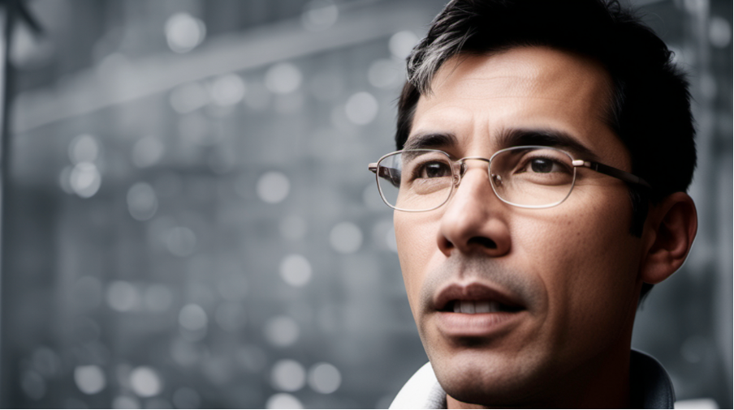
Freedom Through Art: Khue Nguyen’s Journey of Self-Discovery
Art is a powerful medium for personal and collective reflection. Khue Nguyen (embodies?) this, using different artistic forms to navigate the emotional complexities of being a refugee.
Nguyen was born in Vietnam in 1964 under a repressive communist regime. He grew up in a strict family with artistic parents and studied Fine Arts at Ho Chi Minh University. During a politically restricted period, he left the country in 1987 and spent 6 months in a refugee camp in Malaysia, and by 1988 was granted political refugee status in Australia. Here, he began his career as an artist.
Khue’s second body of work begins to explicitly deal with the experiences of Vietnamese diaspora. “From a Home to a Home” was a multi-disciplinary collaboration that used migratory paths of birds along the East Asian-Australasian Flyway as a metaphor to explore how the meaning of home evolves over a lifetime. Experimenting in a different medium, Nguyen combines performance with installation and painting in “Forty Acts of Remembrance”. This project marked the 40th anniversary of the Vietnam War and reflected on how shared history and narrative inform present lives.
His journey of self-discovery also grapples with sexual oppression. As a gay man in a family and culture that repressed homosexuality, Nguyen spent many years afraid to express himself. His portrait “Unleashed,” a finalist in the 2010 Archibald Prize, explores the complex emotional weight of suppressed identity within one’s motherland. He explains, “the octopus at the bottom suggests that my culture grounds me and is still rooted in me but holds me back.” Nguyen’s art continues to confront the refugee experience, offering profound insights into the intersections of migration, identity, and self-expression.
